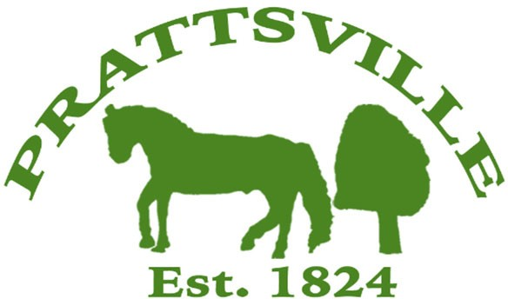Town of Prattsville Board Agenda

Regular Monthly Meeting

February 10th, 2025

1. CALL MEETING TO ORDER
   * Pledge of Allegiance
   * Roll Call
2. APPROVAL OF CLERK'S MINUTES
   * Regular Meeting – January 13th, 2025
   * Organizational Meeting – January 13th, 2025
3. APPROVAL OF MONTHLY FINANCIALS REPORT
4. COMMENTS FROM THE FLOOR / CORRESPONDENCE FROM THE COMMUNITY

# Reports

1. Highway
2. Water District Report
3. Code Enforcement Monthly Report
4. WWTP Report
5. Tax Collector Report

# New Business

1. Court Books and Clerk Books
2. Planning Board appointment – Elliott Oakes
3. Greene County EMS Contract
4. County Waste Agreement
5. Full-time/Part-time benefits
6. Town Historian
7. Town Hall building elevation pre-bid
8. Laura Jane Musser Fund – Knotweed Grant