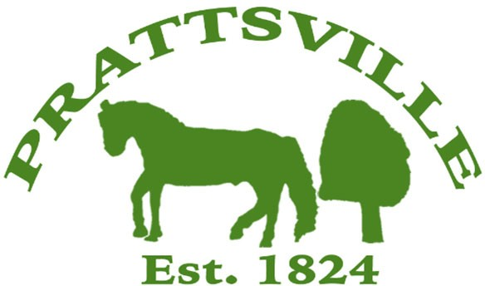Town of Prattsville Board Agenda

Regular Monthly Meeting

January 13th, 2025

1. CALL MEETING TO ORDER
   * Pledge of Allegiance
   * Roll Call
2. APPROVAL OF CLERK'S MINUTES
   * Regular Meeting – December 9th, 2024
   * Special Meeting – End of year meeting, December 26th, 2024
3. APPROVAL OF MONTHLY FINANCIALS REPORT
4. COMMENTS FROM THE FLOOR / CORRESPONDENCE FROM THE COMMUNITY

# Reports

1. Highway
2. Water District Report
3. Code Enforcement Monthly Report
4. WWTP Report

# New Business

1. Organizational Meeting
2. Ambulance Contract
3. AOT Delegate
4. Senior Tax Exemption
5. Low-Income and Disabled Tax Exemption
6. Laberge Contract