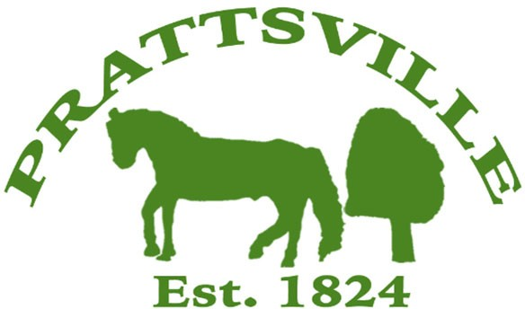Town of Prattsville Board Agenda

Regular Monthly Meeting

September 9th, 2024

1. CALL MEETING TO ORDER
   * Pledge of Allegiance
   * Roll Call
2. APPROVAL OF CLERK'S MINUTES
   * Regular Meeting – August 12th, 2024
3. APPROVAL OF MONTHLY FINANCIALS REPORT
4. COMMENTS FROM THE FLOOR / CORRESPONDENCE FROM THE COMMUNITY
   * Jim Rion

# Old Business / Reports

1. Highway
2. Water District Report
3. Code Enforcement Monthly Report
4. WWTP Report
5. Zadock Pratt Museum Report

# New Business

1. Columbus Day – October Regular Meeting
2. Veterans & Playground Grant
3. Dog Catcher Resignation
4. Plaza water bill