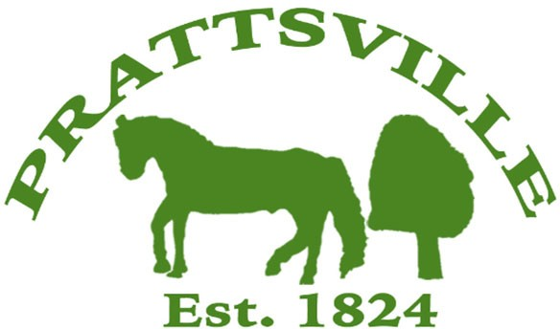Town of Prattsville Board Agenda

Regular Monthly Meeting

May 13th, 2024

1. CALL MEETING TO ORDER
   * Pledge of Allegiance
   * Roll Call
2. APPROVAL OF CLERK'S MINUTES
   * Regular Meeting – April 8th, 2024
   * Special Meeting – March 11th, 2024
3. APPROVAL OF MONTHLY FINANCIALS REPORT
4. COMMENTS FROM THE FLOOR / CORRESPONDENCE FROM THE COMMUNITY

# Old Business / Reports

1. Highway
2. Water District Report
3. Code Enforcement Monthly Report
4. WWTP Report
5. Zadock Pratt Museum Report
6. Tax Collector Report

# New Business

1. DEC Pratt Rock Grant Award
2. Public Parking
3. Town Use Form
4. Pratt Rock Artist Request
5. Local Law to regulate the notification of defects.
6. Resolution for Retention and Disposition Schedule for NY Local Government Records
7. Coalition of Watershed Towns ballot
8. Support letter for the Town of Lexington
9. Water at Conine Ballfield
10. Music on the Town Green
11. RICOH printer